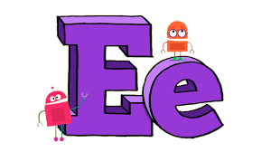E…………………………………………………………………………E………………………………………………………………………...e……………………………………………………………….................e.................................................................................................................

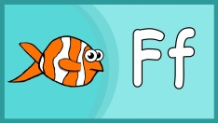F…………………………………………………………………...……F…………………………………………………………………………f…………………………………………………………………............

f…………………………………………………………………............

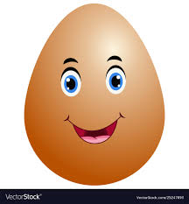egg…………………………………………………………………………………………………………………………………………………..………………………………………………………………….............

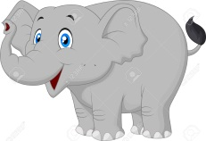elephant………………………………………………………………………………………………………………………………………………………………………………………………………………………

fish……………………………………………………………………………………………………………………………………………………………………………………………………………………….....

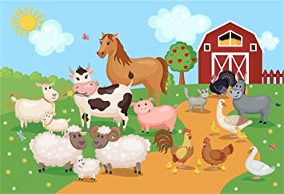farm……………………………………………………………………………………………………………………………………………………...........................................................................................................

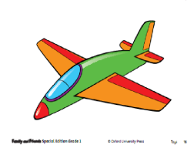plane ………………………………………………………............

………………………………………………………………………………………………………………………………………………….....

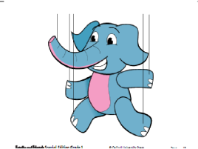puppet …………………………….........................................................

………………………………………………………………………………………………………………………………………………….....

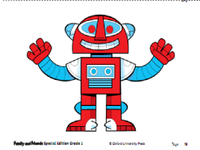robot …………………………….........................................................

………………………………………………………………………………………………………………………………………………….....

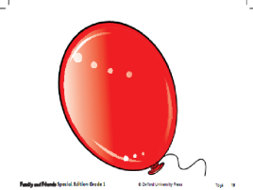baloon …………………………….........................................................

………………………………………………………………………………………………………………………………………………….....

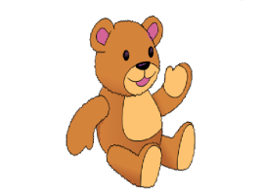teddy bear ……………………………....................................................................

………………………………………………………………………………………………………………………………………………….....

Dặn dò, học sinh copy mỗi từ vào các dòng.🖑🖑🖑🖑